**Trading Strategies in Cryptocurrency**

MATH 5010 Final Project Report (Group #18)

Tianyu Sun(ts3092), Feifei Yan(fy2234), Qianfeng Ying(qy2187)

Yiding Xie(yx2443), Yili Tang(yt2585)

**1 Objective**

This project aims to compare different investment strategies in cryptocurrency market. Specific examples in several cryptocurrencies are presented to show how different strategies are implemented. Two main trading strategies were analyzed and implemented: pairs trading and two-factor value & momentum portfolio strategy. We also talked about the pros and cons of both strategies at the end of the report.

**2 Introduction and Background**

2.1 Introduction

Traditionally, people use various trading strategies to trade assets such as stocks (or equity) to achieve profits. But one problem is that a large amount of historical data and testing over the long term are required to support those strategies. With the surging popularity of Bitcoin, we want to investigate how to implement some of the traditional trading strategies in Bitcoin and how to achieve maximum profits in the crypto world.

Two types of strategies are implemented in our project: pairs trading strategy and 2-factor value and momentum portfolio strategy. In each strategy, tests on the profits for different methods are used and the method yielding the highest return is chosen for each strategy. From above, optimal strategies are developed for investors interested in cryptocurrency.

2.2 Data Source

For pairs trading, divergences between the chosen pair are very important because they provide potential opening and closing trading signals for investors. Therefore, high frequency data is more preferred under this scenario since it will provide more divergences than low frequency data. What’s more, since the volatility for cryptocurrency is pretty high, high frequency data can prevent us from missing trading opportunities.

We find the high frequency (hourly trading) data for cryptocurrency by using API for CryptoCompare. CryptoCompare is a website developed by Cryptopian, which is a professional platform for Cryptocurrency trading located in London. In [computer programming](https://en.wikipedia.org/wiki/Computer_programming), an application programming interface (API) is a set of subroutine definitions, [protocols](https://en.wiktionary.org/wiki/Protocol), and tools for building application software. In general terms, it is a set of clearly defined methods of communication between various software components. Thus, by using CryptoCompare API, we can let our Python program download trading currency data directly from the website. (However, based on restriction from protocol, we can only download 2000 data points at most). After research, among all cryptocurrency, we decide to choose four cryptocurrencies, Bitcoin, Ethereum, Litecoin, Ripple to construct pairs.

Another way, two factor model method is a traditional portfolio management trading strategy, normally trading frame is from months to years. Thus, we still use daily trading data. We get these data basically from websites yahoo.finance and Coindesk. Since we want to construct portfolios, we choose seven cryptocurrencies, Bitcoin, Ethereum, Litecoin, Ripple, Stellar, Dash, and Nem.

The crypto-assets that were used in our project are listed in Appendix.

**3 Pairs Trading Strategy**

3.1 Overview

Pairs trading is the type of market-neutral strategy which works under the assumption that the spread of the two correlated assets will always follow a correlation, and any deviation will weaken the correlation. The trading opportunity is opened up once the spread between two assets deviates and the position can be closed when the spread of two assets converges .

Let  be the price of asset A at time t, and be the price of asset B at time t. Our first step is to test whether A and B are correlated by conducting several tests on the price of two assets. Two assets are defined as correlated pairs if some linear combinations of the prices follow a stationary time series. The next step is to find the perfect timing to open the trading opportunity. By assuming that the linear combination of the two prices is stationary, it can be considered as a mean reverting process. The trading signal can be generated when the combination deviates beyond certain threshold. The task here is to find the threshold which yields the maximum profit and can be used as the optimum trading method for pairs trading.

3.2 Identify correlated instruments

Here we examine three methods to identify correlated pairs.

*3.2.1 Cointegration method*

Assuming that the asset price follows lognormal distribution, then we can fit the log price of each asset into a linear regression model. Let be the price of asset A at time t, and be the price of asset B at time t. Then

The error term here should be non-increasing to make the model accurate. Therefore, our test is whether or where

*3.2.2 Distance method*

The distance method keeps track of the sum of squared differences (Euclidean distance) of the two standardized price.

where , are the standard price of the two assets.

Therefore, for two correlated pairs, we must have constant distance over time. ADF test can be conducted to test for unit root in time series. Here we can let and conduct ADF test to test for constant distance. Note that ADF test uses the model and it tests for .

*3.2.3 Ratio method*

The ratio method calculates the ratio between the two asset price.

For two correlated pairs, we must have constant ratio over time. Here we can let and use ADF test to test for constant ratio.

3.3 Identify potential trade opportunity

After identifying the pair of trading assets, we can use the three methods from the previous part to transform the price. The new price is assumed to follow a stationary process, and any large deviation gives the signal of potential trading opportunity. Our task is to identify the threshold of deviation which yields the maximum of profit.

First, we can transform the two prices into one time series using all three methods we used in the previous part.

Then, when the new price deviate to a certain level, the position is open. We can short sell the asset that is overvalued and long the asset that is undervalued. When the new price converge back to the mean of the new price, we can close the position. Various levels can be tested to determine the level that could yield the maximum profit.

3.4 Implementation

*3.4.1 Identify Pair*

First we use the co-integration method. Recall that we want to test for

where

where is the error term of .

Since we are trying to test for non-increasing error, our test matrix is based on whether is in the confidence interval of at 97.5% confidence level. The result matrix is shown below.

*Table 1: Pair selection result*

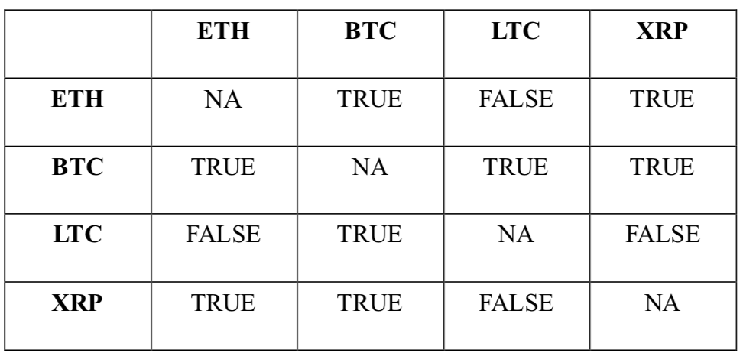

Secondly, we can use distance method to find the pairs with constant distance. The result of the ADF test is shown below.

|  |  |  |  |
| --- | --- | --- | --- |
| Rank | Choice1 | Choice2 | P-value |
| 1 | ETH | BTC | 0.355 |
| 2 | LTC | ETH | 0.153 |
| 3 | BTC | XRP | 0.045 |
| 4 | BTC | LTC | 0.010 |
| 5 | ETH | XRP | 0.010 |
| 6 | LTC | XRP | 0.010 |

*Table 2: Pair ranks based on P-values*

Lastly, we can use ratio method to find the pairs with constant ratio. The result of the ADF test is shown below.

|  |  |  |  |
| --- | --- | --- | --- |
| Rank | Choice1 | Choice2 | P-value |
| 1 | ETH | BTC | 0.918 |
| 2 | LTC | BTC | 0.663 |
| 3 | LTC | ETH | 0.577 |
| 4 | ETH | XRP | 0.557 |
| 5 | LTC | XRP | 0.263 |
| 6 | BTC | XRP | 0.084 |

*Table 3: Pair ranks based on P-values*

*3.4.2 Find optimal trading opportunities*

After testing on several pairs, we decide to use ETH and BTC as our underlying assets. The plot of the new price based on each model is shown below.

|  |  |  |
| --- | --- | --- |
|  |  |  |

*Figure 1: Trading opportunities among three methods*

We consider these new price as a mean reversion process. Then we want to find the threshold which yields the maximum profit. The test for threshold based on each method is shown below.

|  |  |  |
| --- | --- | --- |
|  |  |  |

*Figure 2: Profits among three methods*

*Table 3: Profits Comparison (R Outputs)*

|  |  |  |  |
| --- | --- | --- | --- |
| **Method** | Cointegration | Distance | Ratio |
| **Profits ($)** | 6733.704 | 6026.108 | 5139.072 |

According to Table 3, we can see that cointegration method could yield the maximum profit. The distance method also proves to be a useful tool to yield decent profit. Our test could also provide a useful tool for other traders to make profit in crypto market. Take distance method as an example. Since the maximum profit is achieved when the threshold is 9218.09, we can observe the price, and long BTC(undervalued) and short ETH(overvalued) when the price difference reaches this threshold. We can then close the position once the price difference goes back to 9532.69.

*3.4.3 Simulation*

Using the difference method, we can find potential profit in the future. First we can simulate BTC and ETH using Monte Carlo Simulation. The simulated paths for the later 250 hours is shown below.

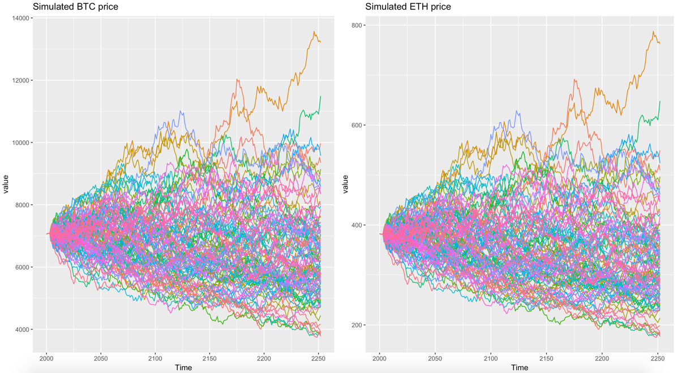

*Figure 3: Simulated Price (BTC vs. ETH)*

Using distance method, we are able to achieve a profit of $2446.28

3.5 Pros and cons

The advantage of pairs trading is that it can make profit even in bear market as long as correlated pairs of assets are identified. Another advantage is its risk-control ability by hedging a undervalued asset with an overvalued asset.

The disadvantage is that we assume that the price will converge after diverge while in reality, it is not the case. If a company is in serious financial troubles, the price will keep on falling until the company goes bankrupt so there will never exist a time when the prices of two companies converge. Therefore, a risk limit is required to guard against situations where two stocks continue to diverge out of sync.

**4 Two factor (Value & Momentum) Portfolio Strategy**

4.1 Overview

The value and momentum two factor model is one of the most commonly used portfolio construction strategy in the world. Here we want to apply its fundamental theory to the cryptocurrency market and see if there’s any consistent outperformance. The time frame is from November 2015 to March 2018.

4.2 Portfolio Construction

*4.2.1 Momentum (Factor 1)*Momentum factor is measured as total return of an index over a specified horizon. The standard time frame used in momentum factor in equity or currency markets is roughly from 3 to 12 months. However, due to the unique nature of high volatility in cryptocurrency market, we decided to use a time frame of one month. If one were to overweight assets with higher momentum and underweight those with lower momentum, one might be able to capture momentum premium over time. Up to now, we did not consider risk at all and assume that it is under a normal distribution. Therefore, we normalized all the cross-sectional momentum values and we were able to obtain the initial factor weights for each currency. Next, we used our risk model (Appendix B) to estimate the covariance matrix and got the initial portfolio risk based on the initial factor weights. Then we re-scaled our factor weights to 1% target risk. Finally, we calculated the compounded return and cumulative return for this factor.

*4.2.2 Value (Factor 2)*

Value factor typically involve a comparison of the market capitalization of a firm to fundamental metrics or firm’s earnings or assets. In equity markets, it would be either P/E or P/B ratio. However, neither of these two ratios exists in cryptocurrencies. After some extensive research, we found out the Network Value to Transactions Ratio is the equivalent version of P/E ratio in the crypto world. The Network Value to Transactions (NVT) ratio measures the dollar value of crypto-asset transaction activity relative to network value. Generally speaking, a “low” market to transaction value denotes an asset which is more cheaply valued per unit of on-chain transaction volume.

In order to minimize the effort of any potential outliers, we decided to use a ranking algorithm as a normalization metric. We first obtained the data of the 14-day average NVT ratios for each of the seven crypto-assets, and then ranked these seven NVT ratios in ascending order. The basic idea behind this method is to capture value risk premium by overweighting assets with higher value measures and underweighting those with lower value measures. Afterwards, from the ranked exposures to value the portfolio holdings using the following formula:

Lastly, we performed the same scaling procedure as with momentum factor, and then calculated the monthly and cumulative return of the value portfolio.

*4.2.3 Description of Risk Model Estimation*

To begin our risk estimation model of the 10 equity index futures in our currency, we used 36 months’ monthly returns in order to estimate our covariance matrix. The formula to compute risk is as follows:

where ∑ denotes the covariance matrix of returns, and w is the weight vector of all the positions.

The matlab code to compute risk is attached in the zip file.

*4.2.4 Combined Portfolio*

The combined portfolio is an equal weighted version of the momentum and value strategies. And the combined portfolio is re-balanced on a monthly basis.

4.3 Implementation

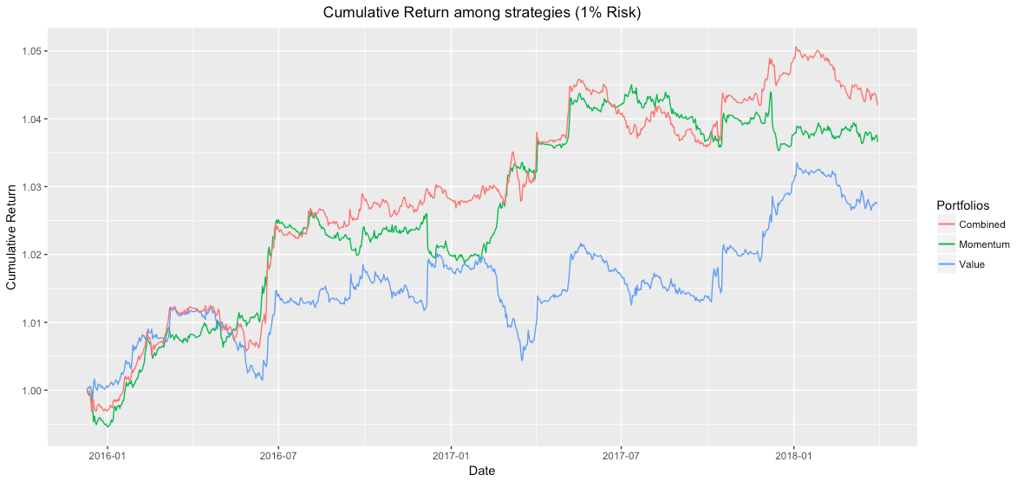

*Figure 4: Cumulative return among portfolios (1% target risk)*

As we can see from the plot above, after we combined the momentum and value strategies, we get a steady increase in the cumulative return, and it is consistently higher than the individual portfolio of either momentum or value strategy.

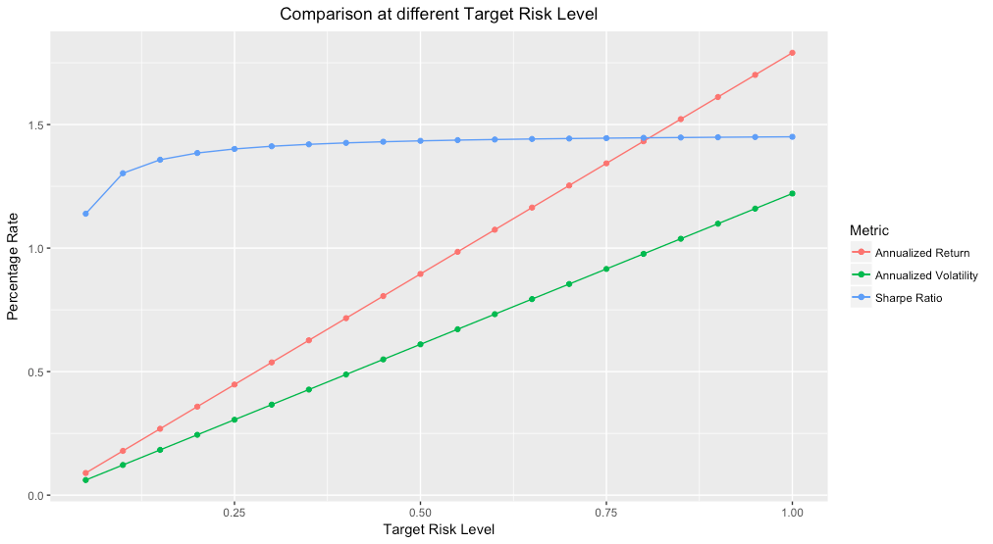

*Figure 5: Comparison (Annualized return, volatility, and Sharpe ratio) vs. Target risk level*

Based on the plot above, we can see that the slopes of the annualized return and volatility lines are simply constant because they are just multiples of each other. Sharpe ratio, however, has a steep slope at first, and then it becomes more flat as the target risk level achieves 0.25 and higher.

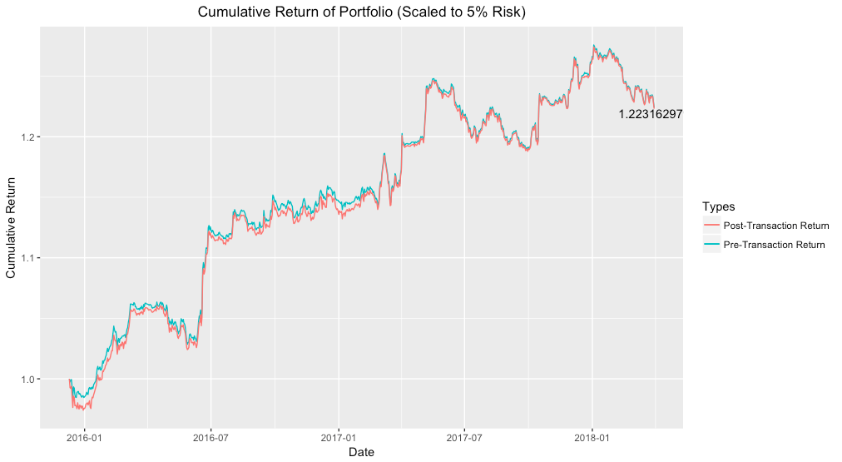

*Figure 6: Cumulative return vs. Transaction cost (5% target risk)*

We successfully gathered the transaction data for four out of the seven cryptocurrencies, and we estimated the other three based on the averages. Considering only the post-transaction value, we were able to achieve an overall return of about 22% during the past two years, given the target annualized volatility of about 5%.

4.4 Results

*Table 4: Combined Strategy Statistics (5% Target Risk)*

|  |  |
| --- | --- |
| Annualized return | 0.089529093 |
| Annualized realized risk | 0.061037316 |
| Annualized return-to-risk ratio | 1.466792763 |
| Maximum drawdown | 0.047049328 |
| Skew | 2.525445656 |
| Sharpe Ratio | 1.139124357 |

**5 Drawbacks**

The drawbacks of our trading strategies include the data accessibility. For example, we did not consider the shorting fees. Also, it is hard to obtain a complete list of high frequency data resources, as the API source only shares the latest 2000 data points for each currency. Last but not least, someone might worry about the feasibility of shorting cryptocurrency, but it turns out that trading platforms like Bitfinex and Poloniex actually supports currency short sales.

**6 Conclusion**

In conclusion, we’ve achieved consistent profits in pairs trading, in either cointegration method, distance method, or ratio method. We’ve also successfully discovered a monthly balanced strategy in a combined portfolio which consists equal weights of momentum and value portfolios.

**7 Reference**

Mitchell , Cory. “The Beginner's Guide to Pairs Trading.” TraderHQ.com, 15 Sept. 2014, traderhq.com/trading-strategies/beginners-guide-to-pairs-trading/.

Folger, Jean. “Guide to Pairs Trading.” Investopedia, Investopedia, 21 Feb. 2018, www.investopedia.com/university/guide-pairs-trading/.

Cameron, Ross. “A Proven Momentum Day Trading Strategy.” Warrior Trading News, 18 June 2015, warriortradingnews.com/a-proven-momentum-day-trading-strategy/10864.

Gautier, Marti. “Download & Play with Cryptocurrencies Historical Data in Python.” Download & Play with Cryptocurrencies Historical Data in Python, 25 Aug. 2017, gmarti.gitlab.io/cryptocurrency/2017/08/25/download-cryptocoins-api-python.html.

Huang, Chien-Feng, et al. “An Intelligent Model for Pairs Trading Using Genetic Algorithms.” Advances in Pediatrics., U.S. National Library of Medicine, 3 Aug. 2015, www.ncbi.nlm.nih.gov/pmc/articles/PMC4538771/.

Zhang, Mengyun. Research on Modern Implications of Pairs Trading . 2012, Research on Modern Implications of Pairs Trading , www.stat.berkeley.edu/users/aldous/Research/Ugrad/Amy_Zhang.pdf.

Gundersen, Ruben Joakim. Statistical Arbitrage: High Frequency Pairs Trading . 2014, Statistical Arbitrage: High Frequency Pairs Trading , brage.bibsys.no/xmlui/bitstream/handle/11250/221265/masterthesis.pdf?sequence=1.

Gatev, Evan, et al. Pairs Trading: Performance of a Relative-Value Arbitrage Rule. 13 Feb. 2006, pdfs.semanticscholar.org/e5f1/b9530a587c5910ceea57ed80270ee22c73b4.pdf.

Tarnopolski, and Mariusz. “Modeling the Price of Bitcoin with Geometric Fractional Brownian Motion: a Monte Carlo Approach.” [1402.1128] Long Short-Term Memory Based Recurrent Neural Network Architectures for Large Vocabulary Speech Recognition, 3 Aug. 2017, arxiv.org/abs/1707.03746.

Hong, K. J., and S. Satchell. “Time Series Momentum Trading Strategy and Autocorrelation Amplification.” Quantitative Finance, vol. 15, no. 9, 2015, pp. 1471–1487., doi:10.1080/14697688.2014.1000951.

Lee, Charles M.C., and Bhaskaran Swaminathan. “Price Momentum and Trading Volume.”Freshwater Biology, Wiley/Blackwell (10.1111), 17 Dec. 2002, onlinelibrary.wiley.com/doi/10.1111/0022-1082.00280/abstract.

ŽEBELYS, TOMAS. Momentum Effect: A Case Study of Baltic States Stock Market . 15 Aug. 2017, theses.ubn.ru.nl/bitstream/handle/123456789/4869/MTHEC_RU_Tomas_Zebelys_s4847385.pdf?sequence.

“Bitcoin Fees for Transactions.” Bitcoin Fees for Transactions, bitcoinfees.earn.com/.

“Bitcoin Avg. Transaction Fee Chart.” BitInfoCharts, bitinfocharts.com/comparison/bitcoin-transactionfees.html.

“Quandl.” Quandl.com, www.quandl.com/data/BCHAIN-Blockchain.

“How Do You Short Cryptocurrencies?” Claymore's Dual Ethereum AMD+NVIDIA GPU Miner v11.7 (Windows/Linux), bitcointalk.org/index.php?topic=1931802.0.

**8 Appendix**

*Table 5: Crypto-assets used in Pairs Trading Strategy*

|  |  |
| --- | --- |
| BTC | Bitcoin |
| ETH | Ethereum |
| LTC | Litecoin |
| XRP | Ripple |

*Table 6: Crypto-assets used in 2-factor Portfolio Strategy*

|  |  |
| --- | --- |
| BTC | Bitcoin |
| ETH | Ethereum |
| LTC | Litecoin |
| XRP | Ripple |
| XLM | Stellar |
| DASH | Dash |
| XEM | Nem |